**Uncovering The Gaming Industry's Hidden Gems: A Comprehensive Analysis Of Video Game Sales**

**INTRODUCTION**

A comprehensive analysis of video game sales is a project which undergoes a complete analysis of video games sold since 1980. It consist of video games with their publisher and platform with the genre of games on which year they were published with sales they made in North America, Japan, Europe and other regions.

**1.1 Overview**

Video game sales analysis is the process of collecting and analyzing data about the sales of video games in order to understand market trends and consumer behavior. Data collection is the process of gathering and measuring information on variables of interest, in an established systematic fashion that enables one to answer stated research questions, test hypotheses, and evaluate outcomes and generate insights from the data.

**1.2 Purpose**

This type of analysis can be useful for a variety of purposes, including identifying the most popular games and genres, predicting future sales, and developing marketing strategies.Video game sales analysis typically involves collecting data from Kaggle sources.

**PROBLEM DEFINITION & DESIGN THINKING**

**2.1 Empathy Map**

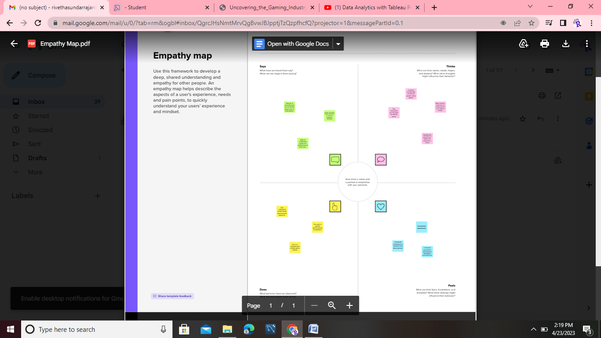

**2.2 Brainstroming Map and Ideation**

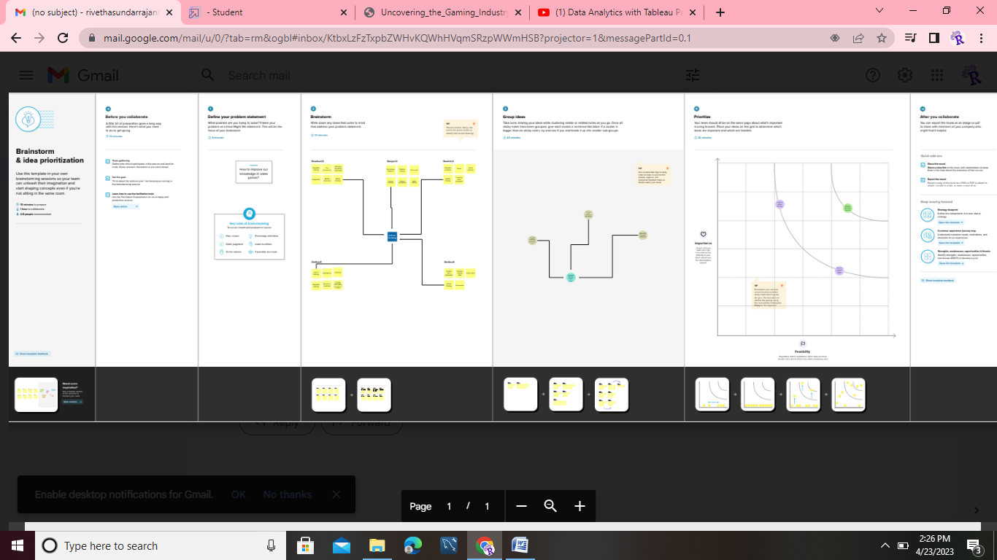

**RESULT**

Analysing sales data from more than 16,500 games. This dataset contains a list of video games with sales greater than 100,000 copies. It also explores future opportunities for the industry, such as the potential for virtual reality and mobile gaming. This data may include information about the number of units sold, the retail price, and the platforms on which the games are played.

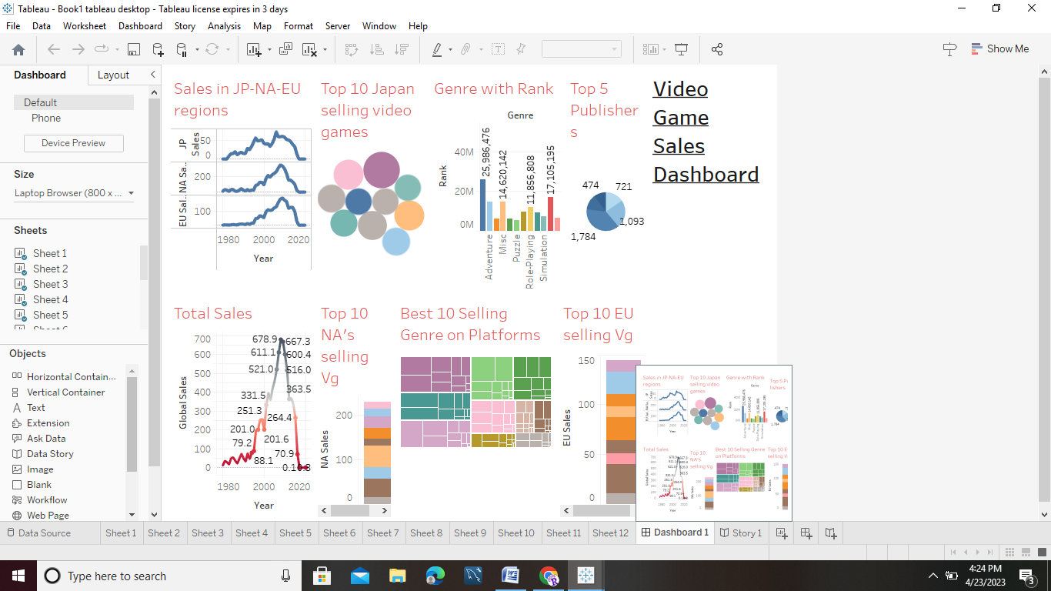

**ADVANTAGES**

* Improved powers of concentration
* Creativity
* Memory
* Languages
* Teamwork.

**DISADVANTAGES**

* sleep deprivation
* insomnia
* circadian rhythm disorders
* depression
* aggression
* anxiety

**APPLICATIONS**

* It is an important part of the video game industry,
* It helps to understand the needs and preferences of consumers
* It also helps to identify opportunities for growth and innovation.

**CONCLUSION**

There are lots of efforts going into creating a single game and due to modern era mobile games other platforms are getting deprived of the attention which had created a lot of awesome experiences for gamers from 1980 – 2023.

**FUTURE SCOPE**

There is a very wide and bright future in game design in India. Students can earn up to 3 Lakh to 5 Lakh PA. Due to less PC penetration, the game industry did not grow the way industry grow in the world. Nasscom estimates that India's gaming industry will reach approx 1 billion.